1 |  | C
 | A
 | B
 | C
 | D
2 |  | D
 | A
 | B
 | C
 | D
3 |  | B
 | A
 | B
 | C
 | D
4 |  | C
 | A
 | B
 | C
 | D
5 |  | D
 | A
 | B
 | C
 | D
6 |  | C
 | A
 | B
 | C
 | D
7 |  | C
 | A
 | B
 | C
 | D
8 |  | A
 | A
 | B
 | C
 | D
9 |  | D
 | A
 | B
 | C
 | D
10 |  | D
 | A
 | B
 | C
 | D
11 |  | B
 | A
 | B
 | C
 | D
12 |  | B
 | A
 | B
 | C
 | D
13 |  | A
 | A
 | B
 | C
 | D
14 |  | A
 | A
 | B
 | C
 | D
15 |  | B
 | A
 | B
 | C
 | D
16 | 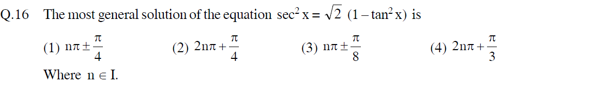 | C
 | A
 | B
 | C
 | D
17 | 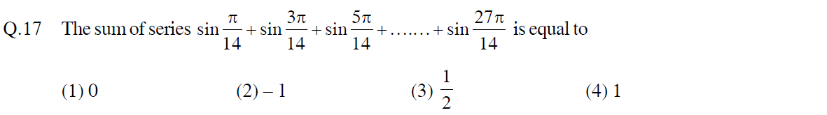 | A
 | A
 | B
 | C
 | D
18 |  | A
 | A
 | B
 | C
 | D
19 |  | C
 | A
 | B
 | C
 | D
20 |  | B
 | A
 | B
 | C
 | D
21 |  | 3
22 |  | 5
23 |  | 45
24 |  | 3
25 |  | 1023
26 |  | B
 | A
 | B
 | C
 | D
27 |  | D
 | A
 | B
 | C
 | D
28 |  | A
 | A
 | B
 | C
 | D
29 |  | B
 | A
 | B
 | C
 | D
30 |  | D
 | A
 | B
 | C
 | D
31 | 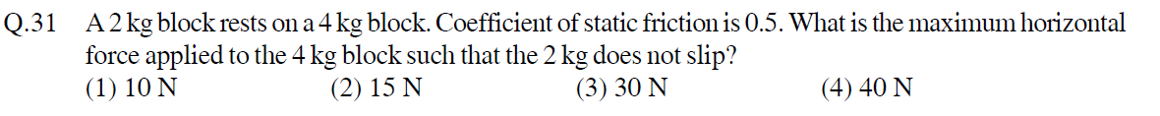 | C
 | A
 | B
 | C
 | D
32 |  | A
 | A
 | B
 | C
 | D
33 |  | B
 | A
 | B
 | C
 | D
34 |  | A
 | A
 | B
 | C
 | D
35 |  | C
 | A
 | B
 | C
 | D
36 |  | B
 | A
 | B
 | C
 | D
37 |  | C
 | A
 | B
 | C
 | D
38 |  | A
 | A
 | B
 | C
 | D
39 |  | C
 | A
 | B
 | C
 | D
40 | 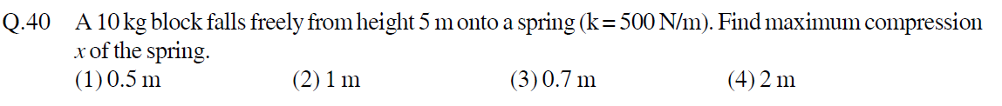 | B
 | A
 | B
 | C
 | D
41 | 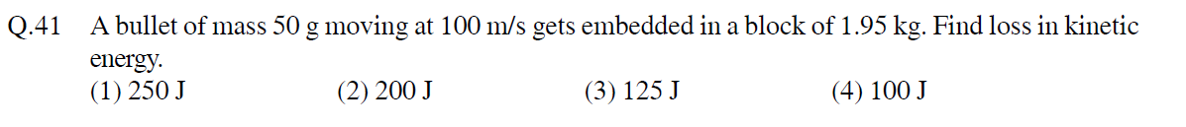 | A
 | A
 | B
 | C
 | D
42 |  | D
 | A
 | B
 | C
 | D
43 |  | B
 | A
 | B
 | C
 | D
44 |  | C
 | A
 | B
 | C
 | D
45 |  | A
 | A
 | B
 | C
 | D
46 |  | 5
47 |  | 6
48 |  | 100
49 |  | 125
50 |  | 700
51 |  | D
 | A
 | B
 | C
 | D
52 |  | A
 | A
 | B
 | C
 | D
53 |  | B
 | A
 | B
 | C
 | D
54 |  | A
 | A
 | B
 | C
 | D
55 |  | D
 | A
 | B
 | C
 | D
56 |  | C
 | A
 | B
 | C
 | D
57 |  | B
 | A
 | B
 | C
 | D
58 | 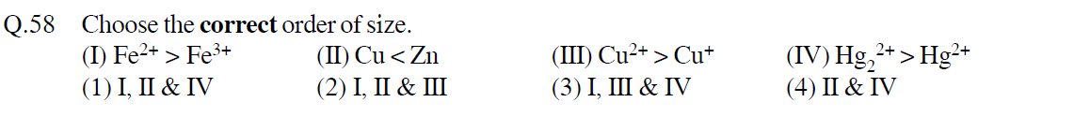 | A
 | A
 | B
 | C
 | D
59 |  | C
 | A
 | B
 | C
 | D
60 |  | A
 | A
 | B
 | C
 | D
61 |  | D
 | A
 | B
 | C
 | D
62 |  | B
 | A
 | B
 | C
 | D
63 |  | B
 | A
 | B
 | C
 | D
64 |  | A
 | A
 | B
 | C
 | D
65 |  | A
 | A
 | B
 | C
 | D
66 |  | A
 | A
 | B
 | C
 | D
67 |  | C
 | A
 | B
 | C
 | D
68 |  | A
 | A
 | B
 | C
 | D
69 | 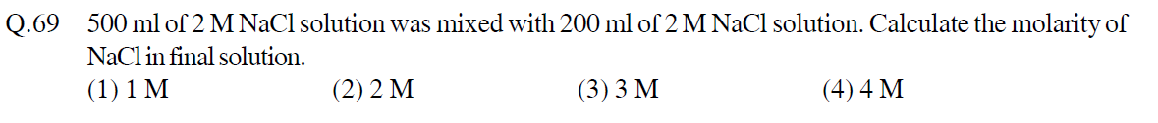 | B
 | A
 | B
 | C
 | D
70 |  | D
 | A
 | B
 | C
 | D
71 |  | 58
72 |  | 2
73 |  | 4
74 |  | 640
75 |  | 4
#1, 2, 3, 4, 5, 6,7, 8, 9, 10, 11, 12, 13, 14, 15, 16, 17, 18, 19, 20 | 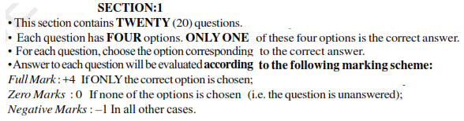
#21, 22, 23, 24, 25 | 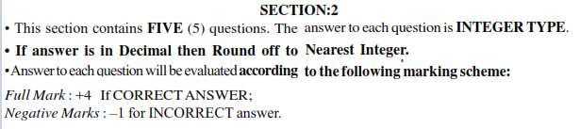
#26, 27, 28, 29, 30, 31, 32, 33, 34, 35, 36, 37, 38, 39, 40, 41, 42, 43, 44, 45
#46, 47, 48, 49, 50
#51, 52, 53, 54, 55, 56, 57, 58, 59, 60, 61, 62, 63, 64, 65, 66, 67, 68, 69, 70
#71, 72, 73, 74, 75

